

|  |  |
| --- | --- |
| **Course Title:** | Fundamentals of Data Engineering |
| **Course Number:** | COE 848 |
| **Semester/Year (e.g.F2016)** | W2021 |
|  |  |
| **Instructor:** | Dr. Faezeh Ensan |
|  |  |
|  |  |
| *Assignment/Lab Number:* | 4 |
| *Assignment/Lab Title:* | Manipulating Data |
|  |  |
|  |  |
| *Submission Date:* | March 16, 2021 |
| *Due Date:* | March 16, 2021 |

|  |  |  |  |  |
| --- | --- | --- | --- | --- |
| **Student LAST Name** | **Student FIRST Name** | **Student Number** | **Section** | **Signature\*** |
| Shreekant | Vatsal | 500771363 | 01 | VS |

*\*By signing above you attest that you have contributed to this written lab report and confirm that all work you have contributed to this lab report is your own work. Any suspicion of copying or plagiarism in this work will result in an investigation of Academic Misconduct and may result in a “0” on the work, an “F” in the course, or possibly more severe penalties, as well as a Disciplinary Notice on your academic record under the Student Code of Academic Conduct, which can be found online at:* [*http://www.ryerson.ca/senate/current/pol60.pdf*](http://www.ryerson.ca/senate/current/pol60.pdf)

**Database Values:**

The following values and data types were built in conjunction with labs 1, 2 and 3.

Customer:

Figure 1: Table of Customers

Order_Des:

Figure 2: Table of Order Description

Product:

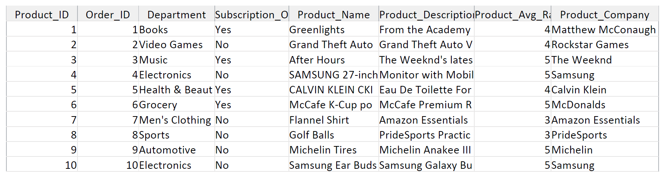

Figure 3: Table of Products

Deals:

Figure 4: Table of Deals

Review:

Figure 5: Table of Reviews

Billing_Detail: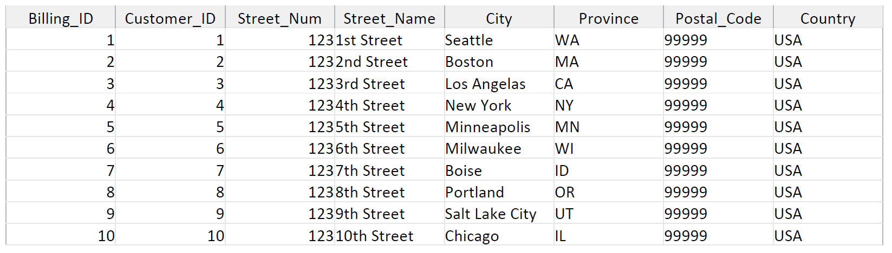

Figure 6: Table of Billing Detail

Places:

Figure 7: Table of ‘Places’ Relationship

Contains:

Figure 8: Table of ‘Contains’ Relationship

Display:

Figure 9: Table of ‘Display’ Relationship

Has:

Figure 10: Table of ‘Has’ Relationship

Write:

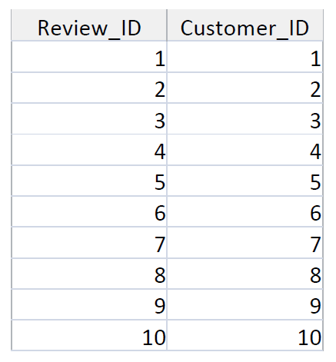

Figure 11: Table of ‘Write’ Relationship

The following are the 10 tasks/queries listed in lab 1:

1. Products offered on the company website, their description, their category and their manufacturer.

The product table is used here to display the 5 attributes listed below.

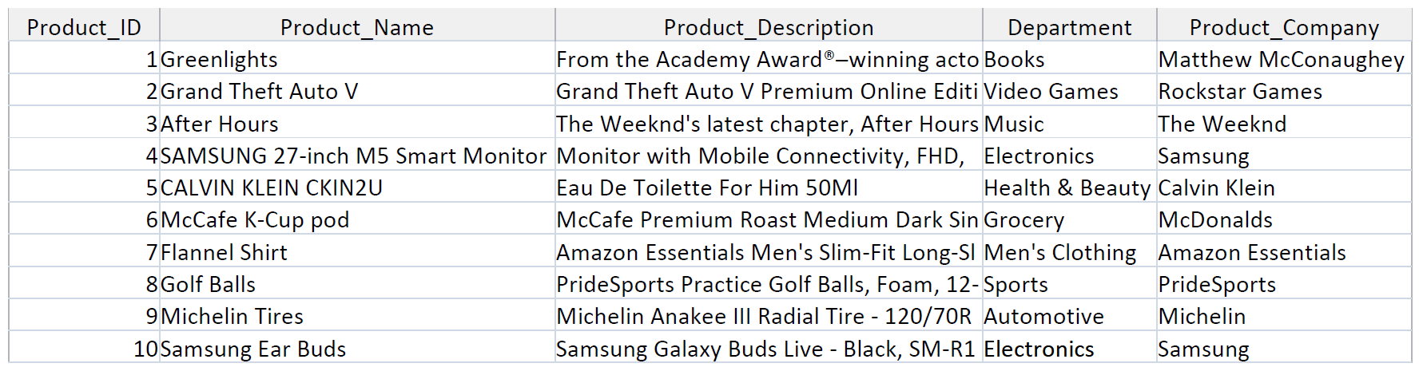

Figure 12: Table of Task #1

Figure 13: SQL Code of Task #1

1. Products listed by their ratings.

The product table is used here to display the 3 attributes listed below. The product average rating are displayed in a descending order.

Figure 14: Table of Task #2

Figure 15: SQL Code of Task #2

1. Are highly rated products built by the same manufacturer?

The highly rated products are displayed here with their respective attributes and the ratings are yet again sorted in a descending order to clarity.

Figure 16: Table of Task #3

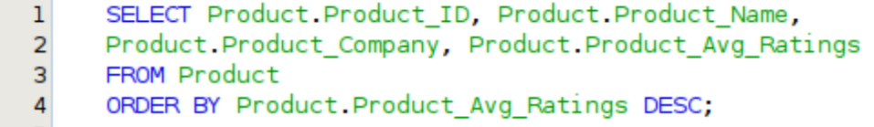

Figure 17: SQL Code of Task #3

1. The products that are bought by the customers on a daily basis.

The product table is used here where the subscription option is equated to a ‘Yes’.

Figure 18: Table of Task #4

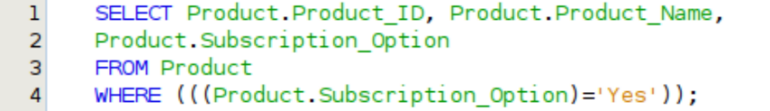

Figure 19: SQL Code of Task #4

1. In the event of a sale/discount day, which products are the least bought?

In order to display the least bought products, the items are sorted by having them equated to ‘Worse-Seller’ entry.

Figure 20: Table of Task #5

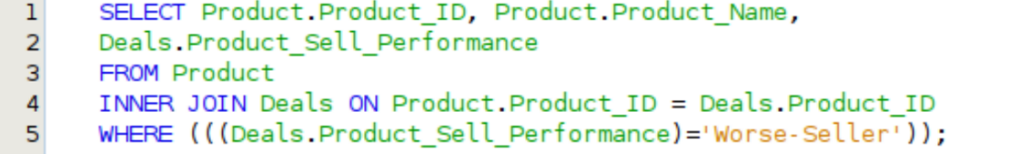

Figure 21: SQL Code of Task #5

1. What products are offered through the company warehouse and not from the manufacturer?

The products available at the warehouse are listed below by sorting the ‘product’ table list in terms of a Boolean value of Warehousing_Offering as ‘Yes’.

Figure 22: Table of Task #6

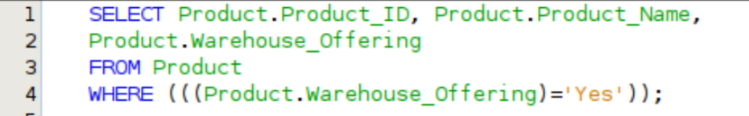

Figure 23: SQL Code of Task #6

1. What products are out of stock and in customer demand?

In order to display the products out of stock, the Product_Availability attribute as part of the products table is equated to ‘No’.

Figure 24: Table of Task #7

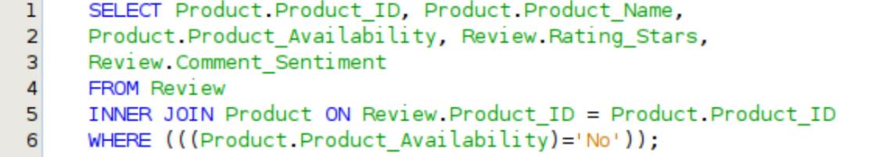

Figure 25: SQL Code of Task #7

1. Products that offer a subscription service in lieu of a one-time purchase.

The products with a subscription service are displayed with a ‘Yes’ and conversely with a ‘No’ where there is no subscription.

Figure 26: Table of Task #8

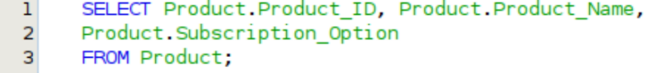

Figure 27: SQL Code of Task #8

1. Products that are released 1 day before the stat holidays.

The products released before the stat holidays are sorted by having the Listing_Date attribute compared with the major stat holiday date ranges. For instance, July 4th, December 25th and January 1st.

Figure 28: Table of Task #9

Figure 29: SQL Code of Task #9

1. The products associated with concerning reviews and high rating.

The products with concerning and high ratings are displayed by inner joining the product and review tables. The Product.ID in Review table acts as a foreign key.

Figure 30: Table of Task #10

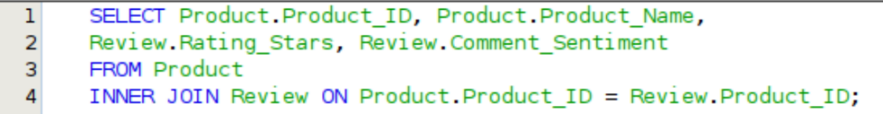

Figure 31: SQL Code of Task #10